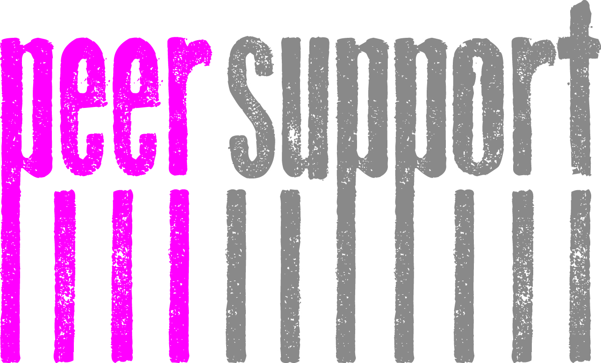
Enhancing Student Support Peer Support Project Update:
As you may know staff and students across the University have been working extremely hard on Peer Support over this Academic Year and we are delighted to announce every School will have some form of Peer Support available to at least one year group by AY 13/14. There are various models developing including PALS, Academic Families, Befriending, Mentoring, House System and much more. The current Phase One of the Peer Support Project will be focused on undergraduates and Phase Two beginning in AY 14/15 will extend the Project to postgraduate and online students following on from the overall ESS Project timeline.

What do we mean by Peer Support:
Peer Support in the context of the University means a student with more experience sharing their knowledge, skills, abilities and expertise with a new or less experienced student. This is a reciprocal relationship, based on mutual respect and understanding and is usually goal focused and time limited. Although all the models are different, some of the common aims are listed below.

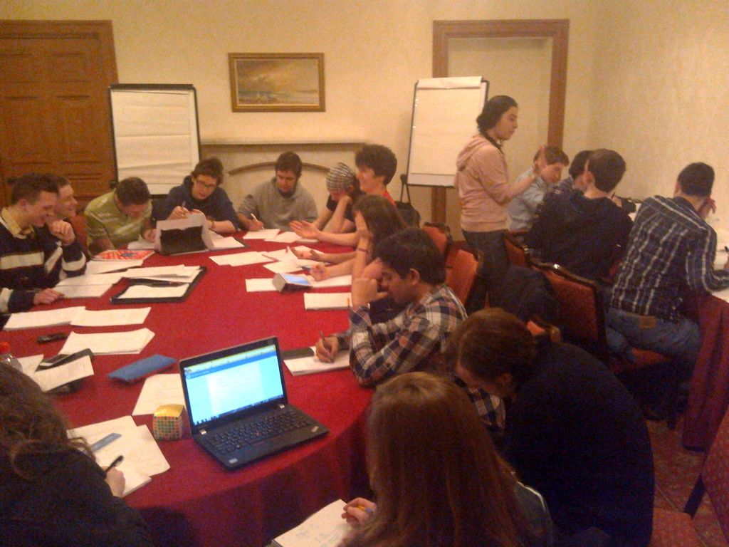
Aims of Peer Support:
- Foster a sense of belonging within the student community
- Create a social space where students can make friends with other students who have common interests
- Encourage the forming of an intellectual community of learners where students can exchange and discuss academic theories and ideas
- Allow a space for incoming students to ask about course choices, common pitfalls or even the best places to go out
- Encourage integration between diverse student communities
- Support students to develop strong inter-personal and communication skills
- Allow senior students to grow in confidence and maturity as they facilitate the learning and positive experience of junior year students
Peer Support Toolkit:
Working in partnership with the University we have created a Peer Support Toolkit; A menu of all the research, resources, training, policies, guidelines and evaluation documentation needed to establish a successful Peer Support Project. Enabling Schools to identify a model(s), which best suits the needs of their students and providing practical guidance as to how to take these forward. You can access this at: http://edin.ac/13P5RsD
The Peer Support models vary from informal to more structured projects, but all those involved will attend training provided by EUSA and the University to ensure that all students receive a quality experience.

What are the benefits of getting involved:
- Potential opportunity to gain the Edinburgh Award
- Develop leadership and teamwork abilities
- Adaptability and strong inter-personal skills
- An understanding of social dynamics
- Potential Reference for future employment
- An opportunity to deepen knowledge of the subject area through activities
- Experience in public speaking
- The ability to plan, run, manage and evaluate workshops
- Develop presentation, time-management and organisational skills
- Develop further graduate attributes
How will we measure this:
EUSA and the University are currently working together to create an evaluation framework and methodology to assess the impact and value of Peer Support across the University. We will also be working to ensure that all Peer Support provisions are offered in line with best practice standards and policy across the University.
Please find below a range of best practice case-studies from across the University:
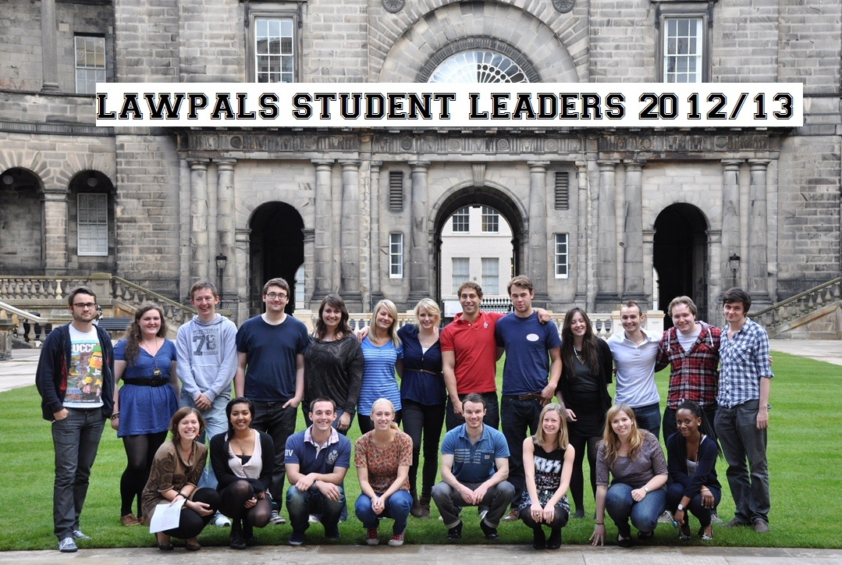
School of Law: LawPALS:
LawPALS is Edinburgh Law School's Peer Assisted Learning Scheme designed to help students adapt to studying law and, for four-year students, studying at university. It aims to ease academic and social transition into Edinburgh Law School – whether students are coming from school, college, employment or university.

Every first year LLB student – no matter their route of entry -is automatically assigned to a LawPALS Group which meets weekly for an hour a week during the first semester. These groups are led by trained (and paid) third and fourth year Student Leaders who are there to help them navigate life at law school through using facilitation skills and their LLB experience. The Student Leaders report to a postgraduate LawPALS Coordinator and the whole programme is overseen by The Director of the Student Experience.
Sessions follow the flow of the timetable so that students cover e.g. legal essay writing skills before their first essay is due. The sessions are embedded within the law student timetable and nothing else runs during these times. This ensures the students have maximum opportunity to participate.

There are separate sessions for our Graduate LLB students (those with a degree in another discipline who come into do the first two years of the LLB) as their study needs differ. These sessions are led by a Diploma in Legal Practice student who came through the Graduate LLB route.
With thanks to Lindsay Jack, Director of the Student Experience, School of Law
BioPALS:

BioPALS is a Peer-Assisted Learning (PAL) scheme set up BY students FOR
students of the Schools of Biological and Biomedical Sciences at the University of
Edinburgh. The Project aims to help students make the most of their degree by creating a
friendly and informal environment for cross-year interaction and support. They promote active studying strategies to help students develop as independent learners, running structured group meetings based around a theme relevant to the course. These sessions are led by trained student facilitators and provide a forum for the exchange of ideas and encourage a more open, engaged, effective and responsible student community. This Project also offers a vehicle to transmit feedback from students to academic and support staff, and the BTO. This has been a hugely successful project thus far.

‘From what I see, BioPALs sessions were very well received by our first year students, many of whom felt that they benefitted significantly from the accumulated experience of their near-peers. The BioPALs facilitators themselves seem also to have developed their confidence and skills greatly through this experience and, judging by the quality of resources that they provide, have given themselves something quite substantial to make their CVs stand out from the crowd’.
With thanks to Dr Heather McQueen, Lecturer, School of Biological Sciences

Katie Scott
Peer Support Development Officer: katie.scott@eusa.ed.ac.uk

